LESSON 2 DEFINITION OF THE SIX TRIGONOMETRIC
FUNCTIONS USING THE UNIT CIRCLE

Topics in this lesson:
1. DEFINITION OF THE SIX TRIGONOMETRIC FUNCTIONS USING A CIRCLE OF RADIUS r
2. DEFINITION OF THE SIX TRIGONOMETRIC FUNCTIONS USING THE UNIT CIRCLE
3. THE SPECIAL ANGLES IN TRIGONOMETRY
4. TEN THINGS EASILY OBTAINED FROM UNIT CIRCLE TRIGONOMETRY
5. THE SIX TRIGONOMETRIC FUNCTIONS OF THE THREE SPECIAL ANGLES IN THE FIRST QUADRANT BY ROTATING COUNTERCLOCKWISE
6. ONE METHOD TO REMEMBER THE TANGENT OF THE SPECIAL ANGLES OF $\frac{π}{6} ( \text{30} ° )$, $\frac{π}{4} ( \text{45} ° )$, AND $\frac{π}{3} ( \text{60} ° )$
7. THE SIX TRIGONOMETRIC FUNCTIONS OF THE REST OF THE SPECIAL ANGLES

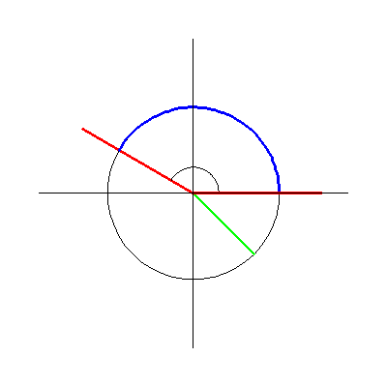
1. DEFINITION OF THE SIX TRIGONOMETRIC FUNCTIONS USING A CIRCLE OF RADIUS r

y

r
s
$P_{r}( θ ) = ( x , y ) →$ $θ$

- r r x
r

- r $x^{2} + y^{2} = r^{2}$

Definition Let $P_{r}( θ ) = ( x , y )$ be the point of intersection of the terminal side of the angle $θ$ with the circle whose equation is $x^{2} + y^{2} = r^{2}$. Then we define the following six trigonometric functions of the angle $θ$

$\text{cos} θ = \frac{x}{r}$ $\text{sec} θ = \frac{r}{x}$ , provided that $x ≠ 0$

$\text{sin} θ = \frac{y}{r}$ $\text{csc} θ = \frac{r}{y}$, provided that $y ≠ 0$

$\text{tan} θ = \frac{y}{x}$, provided that $x ≠ 0$ $\text{cot} θ = \frac{x}{y}$, provided that $y ≠ 0$

NOTE: By definition, the secant function is the reciprocal of the cosine function. The cosecant function is the reciprocal of the sine function. The cotangent function is the reciprocal of the tangent function.

Back to Topics List

2. DEFINITION OF THE SIX TRIGONOMETRIC FUNCTIONS USING THE UNIT CIRCLE

Since you can use any size circle to define the six trigonometric functions, the best circle to use would be the Unit Circle, whose radius r is 1. Using the Unit Circle, we get the following special definition.

Definition Let $P ( θ ) = ( x , y )$ be the point of intersection of the terminal side of the angle $θ$ with the Unit Circle. Since $r = 1$ for the Unit Circle, then by the definition above, we get the following definition for the six trigonometric functions of the angle $θ$ using the Unit Circle

$\text{cos} θ = x$ $\text{sec} θ = \frac{1}{x}$ , provided that $x ≠ 0$

$\text{sin} θ = y$ $\text{csc} θ = \frac{1}{y}$, provided that $y ≠ 0$

$\text{tan} θ = \frac{y}{x}$, provided that $x ≠ 0$ $\text{cot} θ = \frac{x}{y}$, provided that $y ≠ 0$

y

1
s
$P ( θ ) = ( x , y ) →$ $θ$

- 1 1 x
1

- 1 $x^{2} + y^{2} = 1$ (The Unit Circle)

NOTE: The definition of the six trigonometric functions of the angle $θ$ in terms of the Unit Circle says that the cosine of the angle $θ$ is the x-coordinate of the point of intersection of the terminal side of the angle $θ$ with the Unit Circle. This definition also says that the sine of the angle $θ$ is the y-coordinate of the point of intersection of the terminal side of the angle $θ$ with the Unit Circle. The tangent of the angle $θ$ is the y-coordinate of the point of intersection of the terminal side of the angle $θ$ with the Unit Circle divided by the x-coordinate of the point of intersection. The secant function is still the reciprocal of the cosine function, the cosecant function is still the reciprocal of the sine function, and the cotangent function is still the reciprocal of the tangent function.

Examples Find the exact value of the six trigonometric functions for the following angles.

1. $θ = 0 °$

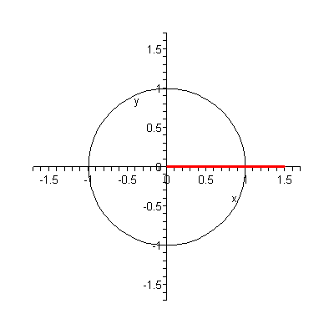

$P ( 0 ° ) = ( 1 , 0 )$

$\text{cos} 0 ° = x = 1$ $\text{sec} 0 ° = \frac{1}{\text{cos} 0 °} = \frac{1}{1} = 1$

$\text{sin} 0 ° = y = 0$ $\text{csc} 0 ° = \frac{1}{\text{sin} 0 °} = \frac{1}{0}$ = undefined

$\text{tan} 0 ° = \frac{y}{x} = \frac{0}{1} = 0$ $\text{cot} 0 ° = \frac{1}{\text{tan} 0 °} = \frac{1}{0}$ = undefined

2. $α = \frac{π}{2}$

NOTE: This is the $9 0 °$ angle in units of degrees.
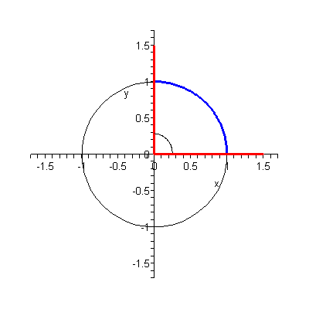

$P \left(\frac{π}{2}\right) = ( 0 , 1 )$

$\text{cos} \left(\frac{π}{2}\right) = x = 0$ $\text{sec} \left(\frac{π}{2}\right) = \frac{1}{\text{cos} \left(\frac{π}{2}\right)} = \frac{1}{0} =$ undefined

$\text{sin} \left(\frac{π}{2}\right) = y = 1$ $\text{csc} \left(\frac{π}{2}\right) = \frac{1}{\text{sin} \left(\frac{π}{2}\right)} = \frac{1}{1} = 1$

$\text{tan} \left(\frac{π}{2}\right) = \frac{y}{x} = \frac{1}{0}$ = undefined $\text{cot} \left(\frac{π}{2}\right) = \frac{1}{\text{tan} \left(\frac{π}{2}\right)} = \frac{x}{y} = \frac{0}{1} = 0$

3. $θ = π$

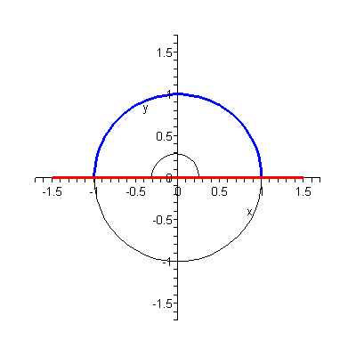
NOTE: This is the $\text{18} 0 °$ angle in units of degrees.

$$P ( π ) = ( − 1 , 0 )$$

$\text{cos} π = x = − 1$ $\text{sec} π = \frac{1}{\text{cos} π} = \frac{1}{− 1} = − 1$

$\text{sin} π = y = 0$ $\text{csc} π = \frac{1}{\text{sin} π} = \frac{1}{0}$ = undefined

$\text{tan} π = \frac{y}{x} = \frac{0}{− 1} = 0$ $\text{cot} π = \frac{1}{\text{tan} π} = \frac{1}{0}$ = undefined

4. $γ = \text{270} °$

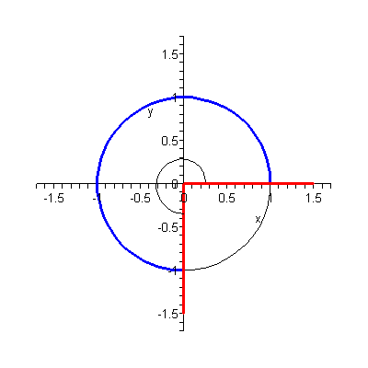
NOTE: This is the $\frac{3 π}{2}$ angle in units of radians.

$P ( \text{270} ° ) = ( 0 , − 1 )$

$\text{cos} \text{270} ° = 0$ $\text{sec} \text{270} ° = \frac{1}{0}$ = undefined

$\text{sin} \text{270} ° = − 1$ $\text{csc} \text{270} ° = − 1$

$\text{tan} \text{270} ° = \frac{− 1}{0}$ = undefined $\text{cot} \text{270} ° = \frac{0}{− 1} = 0$

5. $φ = 2 π$

NOTE: This is the $\text{36} 0 °$ angle in units of degrees.

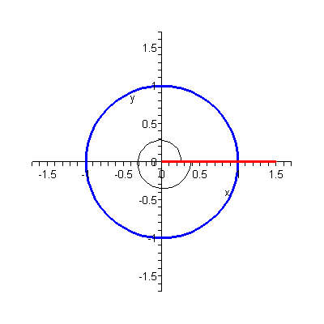

$P ( 2 π ) = ( 1 , 0 )$

$\text{cos} 2 π = 1$ $\text{sec} 2 π = 1$

$\text{sin} 2 π = 0$ $\text{csc} 2 π = \frac{1}{0}$ = undefined

$\text{tan} 2 π = \frac{0}{1} = 0$ $\text{cot} 2 π = \frac{1}{0}$ = undefined

6. $θ = − \text{90} °$

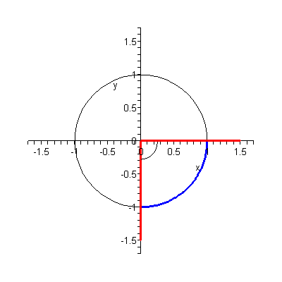
NOTE: This is the $− \frac{π}{2}$ angle in units of radians.

$P ( − \text{90} ° ) = ( 0 , − 1 )$

$\text{cos} ( − \text{90} ° ) = 0$ $\text{sec} ( − \text{90} ° ) = \frac{1}{0}$ = undefined

$\text{sin} ( − \text{90} ° ) = − 1$ $\text{csc} ( − \text{90} ° ) = − 1$

$\text{tan} ( − \text{90} ° ) = \frac{− 1}{0}$ = undefined $\text{cot} ( − \text{90} ° ) = \frac{0}{− 1} = 0$

7. $α = − \text{180} °$

NOTE: This is the $− π$ angle in units of radians.
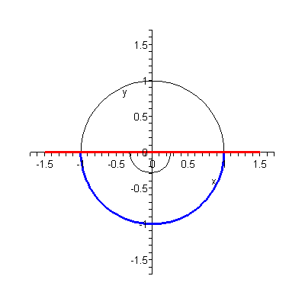

$P ( − \text{180} ° ) = ( − 1 , 0 )$

$\text{cos} ( − \text{180} ° ) = − 1$ $\text{sec} ( − \text{180} ° ) = − 1$

$\text{sin} ( − \text{180} ° ) = 0$ $\text{csc} ( − \text{180} ° ) = \frac{1}{0}$ = undefined

$\text{tan} ( − \text{180} ° ) = \frac{0}{− 1} = 0$ $\text{cot} ( − \text{180} ° ) = \frac{1}{0}$ = undefined

8. $β = − \frac{3 π}{2}$

NOTE: This is the $− \text{27} 0 °$ angle in units of degrees.
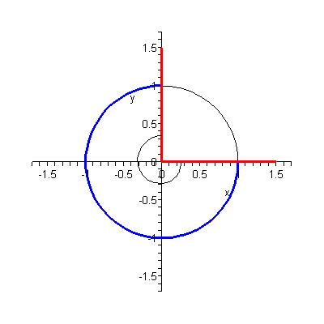

$P \left(− \frac{3 π}{2}\right) = ( 0 , 1 )$

$\text{cos} \left(− \frac{3 π}{2}\right) = 0$ $\text{sec} \left(− \frac{3 π}{2}\right) = \frac{1}{0}$ = undefined

$\text{sin} \left(− \frac{3 π}{2}\right) = 1$ $\text{csc} \left(− \frac{3 π}{2}\right) = 1$

$\text{tan} \left(− \frac{3 π}{2}\right) = \frac{1}{0}$ = undefined $\text{cot} \left(− \frac{3 π}{2}\right) = \frac{0}{1} = 0$

9. $γ = − \text{360} °$

NOTE: This is the $− 2 π$ angle in units of radians.

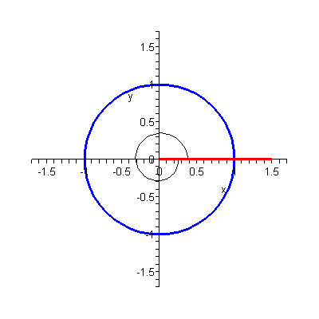

$P ( − \text{360} ° ) = ( 1 , 0 )$

$\text{cos} ( − \text{360} ° ) = 1$ $\text{sec} ( − \text{360} ° ) = 1$

$\text{sin} ( − \text{360} ° ) = 0$ $\text{csc} ( − \text{360} ° ) = \frac{1}{0}$ = undefined

$\text{tan} ( − \text{360} ° ) = \frac{0}{1} = 0$ $\text{cot} ( − \text{360} ° ) = \frac{1}{0}$ = undefined

Back to Topics List

3. THE SPECIAL ANGLES IN TRIGONOMETRY

The Special Angles (in radians) in trigonometry are

$$0 , ± \frac{π}{6} , ± \frac{π}{4} , ± \frac{π}{3} , ± \frac{π}{2} , ± \frac{2 π}{3} , ± \frac{3 π}{4} , ± \frac{5 π}{6} , ± π ,$$

$$± \frac{7 π}{6} , ± \frac{5 π}{4} , ± \frac{4 π}{3} , ± \frac{3 π}{2} , ± \frac{5 π}{3} , ± \frac{7 π}{4} , ± \frac{\text{11} π}{6} , ± 2 π$$

The Special Angles (in degrees) in trigonometry are

$$0 ° , ± \text{30} ° , ± \text{45} ° , ± \text{60} ° , ± \text{90} ° , ± \text{120} ° , ± \text{135} ° , ± \text{150} ° , ± \text{180} ° ,$$

$$± \text{210} ° , ± \text{225} ° , ± \text{240} ° , ± \text{270} ° , ± \text{300} ° , ± \text{315} ° , ± \text{330} ° , ± \text{360} °$$

Here are the coordinates of the point of intersection of the terminal side of the positive Special Angles with the Unit Circle. These coordinates could be used to find the exact value of the six trigonometric functions of these Special Angles.

Here are the coordinates of the point of intersection of the terminal side of the negative Special Angles with the Unit Circle. These coordinates could be used to find the exact value of the six trigonometric functions of these Special Angles.

Back to Topics List

4. TEN THINGS EASILY OBTAINED FROM UNIT CIRCLE TRIGONOMETRY

1. The x-coordinate of any point on the Unit Circle satisfies the condition $− 1 ≤ x ≤ 1$. Since we get the cosine of any angle $θ$ from the x-coordinate of the point of intersection of the terminal side of the angle $θ$ with the Unit Circle, then $− 1 ≤ \text{cos} θ ≤ 1$ for all $θ$. Thus, the range of the cosine function is the closed interval $[ − 1 , 1 ]$.

2. The y-coordinate of any point on the Unit Circle satisfies the condition $− 1 ≤ y ≤ 1$. Since we get the sine of any angle $θ$ from the y-coordinate of the point of intersection of the terminal side of the angle $θ$ with the Unit Circle, then $− 1 ≤ \text{sin} θ ≤ 1$ for all $θ$. Thus, the range of the sine function is also the closed interval $[ − 1 , 1 ]$.

3. By definition, $\text{tan} θ = \frac{y}{x}$, where x is the x-coordinate and y is the y-coordinate of the point of intersection of the terminal side of the angle θ with the Unit Circle. Since $\text{cos} θ = x$ and $\text{sin} θ = y$ by definition, then $\text{tan} θ = \frac{\text{sin} θ}{\text{cos} θ}$ for all $θ$.

4. Similarly, since $\text{sec} θ = \frac{1}{x}$ by definition, then $\text{sec} θ = \frac{1}{\text{cos} θ}$ for all $θ$.

5. Similarly, since $\text{csc} θ = \frac{1}{y}$ by definition, then $\text{csc} θ = \frac{1}{\text{sin} θ}$ for all $θ$.

6. Similarly, since $\text{cot} θ = \frac{x}{y}$ by definition, then $\text{cot} θ = \frac{\text{cos} θ}{\text{sin} θ}$ for all $θ$.

7. The equation of the Unit Circle is $x^{2} + y^{2} = 1$. This equation says that if you take the x-coordinate and the y-coordinate of a point on the Unit Circle, square them and then add, you will get the value of 1. Since we get the cosine of any angle $θ$ from the x-coordinate and the sine of the angle $θ$ from the y-coordinate of the point of intersection of the terminal side of the angle $θ$ with the Unit Circle, then we obtain the equation

$( \text{cos} θ )^{2} + ( \text{sin} θ )^{2} = 1$,

which we write as

${\text{cos}}^{2} θ + {\text{sin}}^{2} θ = 1$ for all $θ$.

This equation is the first of the three Pythagorean Identities.

8. Taking the equation ${\text{cos}}^{2} θ + {\text{sin}}^{2} θ = 1$ and dividing both sides of the equation by ${\text{cos}}^{2} θ$ we obtain the second Pythagorean Identity:

$\frac{{\text{cos}}^{2} θ + {\text{sin}}^{2} θ}{{\text{cos}}^{2} θ} = \frac{1}{{\text{cos}}^{2} θ}$ ⇒ $\frac{{\text{cos}}^{2} θ}{{\text{cos}}^{2} θ} + \frac{ {\text{sin}}^{2} θ}{{\text{cos}}^{2} θ} = \frac{1}{{\text{cos}}^{2} θ}$ ⇒

$1 + {\left(\frac{\text{sin} θ}{\text{cos} θ}\right)}^{2} = {\left(\frac{1}{\text{cos} θ}\right)}^{2}$ ⇒ $1 + {\text{tan}}^{2} θ = {\text{sec}}^{2} θ$ ⇒

${\text{sec}}^{2} θ − {\text{tan}}^{2} θ = 1$ for all $θ$.

9. Similarly, taking the equation ${\text{cos}}^{2} θ + {\text{sin}}^{2} θ = 1$ and dividing both sides of the equation by ${\text{sin}}^{2} θ$ you will obtain the third Pythagorean Identity:

${\text{csc}}^{2} θ − {\text{cot}}^{2} θ = 1$ for all $θ$.

10. The sign of the cosine, sine, and tangent functions in the Four Quadrants:

y
$\begin{aligned}( − , + ) \\ ( \text{cos} θ , \text{sin} θ )\end{aligned}$ $\begin{aligned}( + , + ) \\ ( \text{cos} θ , \text{sin} θ )\end{aligned}$

$\text{tan} θ = \frac{y}{x} = \frac{( + )}{( − )} = ( − )$ $\text{tan} θ = \frac{y}{x} = \frac{( + )}{( + )} = ( + )$

x $\begin{aligned}( − , − ) \\ ( \text{cos} θ , \text{sin} θ )\end{aligned}$ $\begin{aligned}( + , − ) \\ ( \text{cos} θ , \text{sin} θ )\end{aligned}$

$\text{tan} θ = \frac{y}{x} = \frac{( − )}{( − )} = ( + )$ $\text{tan} θ = \frac{y}{x} = \frac{( − )}{( + )} = ( − )$

Back to Topics List

5. THE SIX TRIGONOMETRIC FUNCTIONS OF THE THREE SPECIAL ANGLES IN THE FIRST QUADRANT BY ROTATING COUNTERCLOCKWISE
THE POINT OF INTERSECTION OF THE ANGLE $\frac{π}{6} ( \text{30} ° )$ WITH THE UNIT CIRCLE
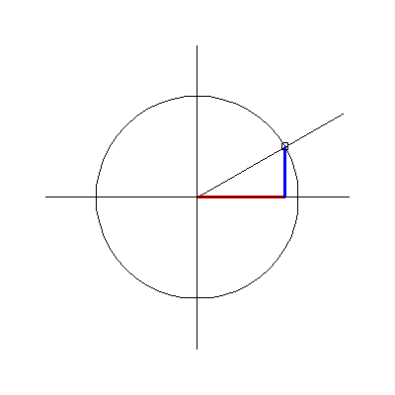
y

1

$P \left(\frac{π}{6}\right) = \left(\frac{\sqrt{ 3}}{2} , \frac{1}{2}\right)$

− 1 1 x

− 1

This picture shows us that the x-coordinate is greater than the y-coordinate of the point $P \left(\frac{π}{6}\right)$, which is the point of intersection of the angle $\frac{π}{6} ( \text{30} ° )$ with the Unit Circle. Thus,

$\text{cos} \frac{π}{6} = \frac{\sqrt{ 3}}{2}$ $\text{sec} \frac{π}{6} = \frac{2}{\sqrt{ 3}}$
$\text{sin} \frac{π}{6} = \frac{1}{2}$ $\text{csc} \frac{π}{6} = 2$

$\text{tan} \frac{π}{6} = \frac{\frac{1}{2}}{\frac{\sqrt{ 3}}{2}} = \frac{1}{\sqrt{ 3}}$ $\text{cot} \frac{π}{6} = \sqrt{ 3}$

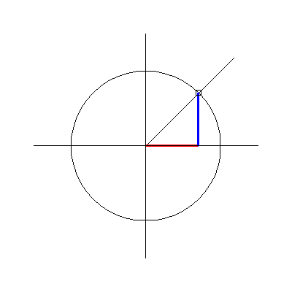
THE POINT OF INTERSECTION OF THE ANGLE $\frac{π}{4} ( \text{45} ° )$ WITH THE UNIT CIRCLE

y

1

$P \left(\frac{π}{4}\right) = \left(\frac{\sqrt{ 2}}{2} , \frac{\sqrt{ 2}}{2}\right)$

− 1 1 x

− 1

This picture shows us that the x-coordinate is same as the y-coordinate of the point $P \left(\frac{π}{4}\right)$, which is the point of intersection of the angle $\frac{π}{4} ( \text{45} ° )$ with the Unit Circle. Thus,

$\text{cos} \frac{π}{4} = \frac{\sqrt{ 2}}{2}$ $\text{sec} \frac{π}{4} = \frac{2}{\sqrt{ 2}} = \sqrt{ 2}$

$\text{sin} \frac{π}{4} = \frac{\sqrt{ 2}}{2}$ $\text{csc} \frac{π}{4} = \frac{2}{\sqrt{ 2}} = \sqrt{ 2}$

$\text{tan} \frac{π}{4} = \frac{\frac{\sqrt{ 2}}{2}}{\frac{\sqrt{ 2}}{2}} = 1$ $\text{cot} \frac{π}{4} = 1$

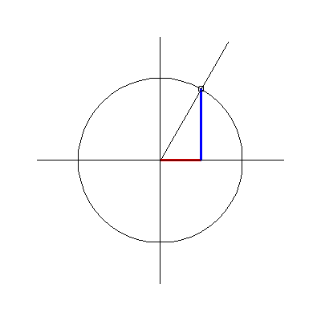
THE POINT OF INTERSECTION OF THE ANGLE $\frac{π}{3} ( \text{60} ° )$ WITH THE UNIT CIRCLE

y

1
$P \left(\frac{π}{3}\right) = \left(\frac{1}{2} , \frac{\sqrt{ 3}}{2}\right)$

− 1 1 x

− 1

This picture shows us that the x-coordinate is less than the y-coordinate of the point $P \left(\frac{π}{3}\right)$, which is the point of intersection of the angle $\frac{π}{3} ( \text{60} ° )$ with the Unit Circle. Thus,

$\text{cos} \frac{π}{3} = \frac{1}{2}$ $\text{sec} \frac{π}{3} = 2$

$\text{sin} \frac{π}{3} = \frac{\sqrt{ 3}}{2}$ $\text{csc} \frac{π}{3} = \frac{2}{\sqrt{ 3}}$

$\text{tan} \frac{π}{3} = \frac{\frac{\sqrt{ 3}}{2}}{\frac{1}{2}} = \sqrt{ 3}$ $\text{cot} \frac{π}{3} = \frac{1}{\sqrt{ 3}}$

Back to Topics List

6. ONE METHOD TO REMEMBER THE TANGENT OF THE SPECIAL ANGLES OF $\frac{π}{6} ( \text{30} ° )$, $\frac{π}{4} ( \text{45} ° )$, AND $\frac{π}{3} ( \text{60} ° )$

You will need to remember the three numbers $1 , \sqrt{ 3} ,$and $\frac{1}{\sqrt{ 3}}$. Arrange the angles $\frac{π}{6} ( \text{30} ° )$, $\frac{π}{4} ( \text{45} ° )$, and $\frac{π}{3} ( \text{60} ° )$ from smallest to largest. Then arrange the three numbers from smallest to largest:

$\frac{π}{6} ( \text{30} ° )$ $\frac{π}{4} ( \text{45} ° )$ $\frac{π}{3} ( \text{60} ° )$
$\begin{aligned} | \\ ↓\end{aligned}$ $\begin{aligned} | \\ ↓\end{aligned}$ $\begin{aligned} | \\ ↓\end{aligned}$ Tangent
$\frac{1}{\sqrt{ 3}}$ $1$ $\sqrt{ 3}$

In other words, the tangent of the smallest angle of $\frac{π}{6} ( \text{30} ° )$ is the smallest number of $\frac{1}{\sqrt{ 3}}$, the tangent of the largest angle of $\frac{π}{3} ( \text{60} ° )$ is the largest number of $\sqrt{ 3}$, and the tangent of the middle angle of $\frac{π}{4} ( \text{45} ° )$ is the middle number of $1$.

Back to Topics List

7. THE SIX TRIGONOMETRIC FUNCTIONS OF THE REST OF THE SPECIAL ANGLES

To find the trigonometric functions for the special angles in the II, III, and IV quadrants by rotating counterclockwise and for all the special angles in the IV, III, II, and I quadrants by rotating clockwise, we make use of the reference angle of these angles. Reference angles will be discussed in Lesson 3.

Back to Topics List

