LESSON 3 REFERENCE ANGLES

Topics in this lesson:
1. THE DEFINITION AND EXAMPLES OF REFERENCE ANGLES
2. THE REFERENCE ANGLE OF THE SPECIAL ANGLES
3. USING A REFERENCE ANGLE TO FIND THE VALUE OF THE SIX TRIGONOMETRIC FUNCTIONS

1. THE DEFINITION AND EXAMPLES OF REFERENCE ANGLES

Definition The reference angle of the angle $θ$, denoted by $θ '$, is the acute angle determined by the terminal side of $θ$ and either the positive or negative x-axis.

Recall, an acute angle is an angle whose measurement is greater than $0 °$ and less than $\text{90} °$.

NOTE: By definition, the reference angle is an acute angle. Thus, any angle whose terminal side lies on either the x-axis or the y-axis does not have a reference angle.

Examples Find the reference angle $θ '$ for the following angles $θ$ made by rotating counterclockwise.

1. $θ$ is in the I quadrant.

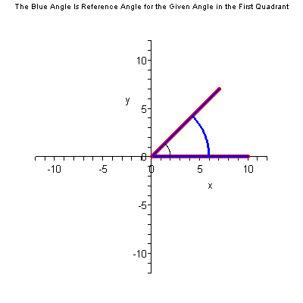

Animation of the reference angle.

$θ '$
$θ$

Relationship between $θ$ and $θ '$: $θ = θ '$
2. $θ$ is in the II quadrant.

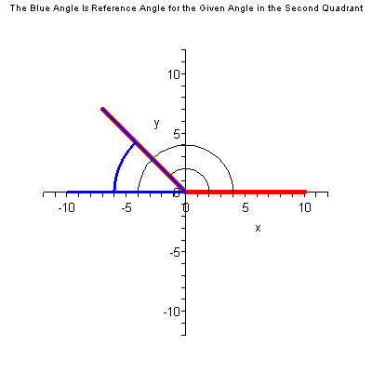

Animation of the reference angle.

$θ '$ $θ$

Relationship between $θ$ and $θ '$:
$θ ' = π − θ$ OR $θ ' = \text{180} ° − θ$
OR
$θ + θ ' = π$ OR $θ + θ ' = \text{180} °$

3. $θ$ is in the III quadrant.

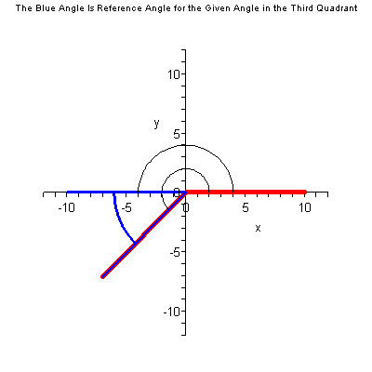

Animation of the reference angle.

$θ$

$θ '$

Relationship between $θ$ and $θ '$:
$θ ' = θ − π$ OR $θ ' = θ − \text{180} °$
OR
$π + θ ' = θ$ OR $\text{180} ° + θ ' = θ$
4. $θ$ is in the IV quadrant.
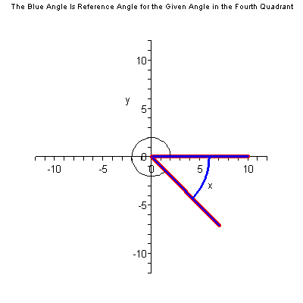

Animation of the reference angle.

$θ$

$θ '$

Relationship between $θ$ and $θ '$:
$θ ' = 2 π − θ$ OR $θ ' = \text{360} ° − θ$
OR
$θ + θ ' = 2 π$ OR $θ + θ ' = \text{360} °$

Examples Find the reference angle $θ '$ for the following angles $θ$ made by rotating clockwise.

1. $θ$ is in the IV quadrant.
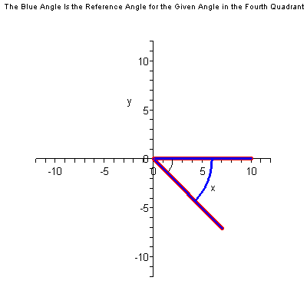

Animation of the reference angle.

$θ$
$θ '$

Relationship between $θ$ and $θ '$: $θ ' = \left| θ \right|$
2. $θ$ is in the III quadrant.

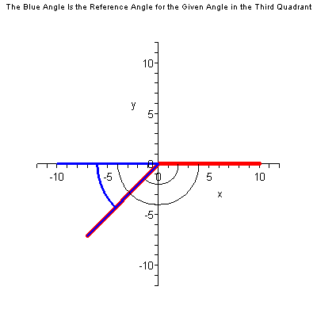

Animation of the reference angle.

$θ '$ $θ$

Relationship between $θ$ and $θ '$:
$θ ' = π − \left| θ \right|$ OR $θ ' = \text{180} ° − \left| θ \right|$
OR
$\left| θ \right| + θ ' = π$ OR $\left| θ \right| + θ ' = \text{180} °$

3. $θ$ is in the II quadrant.

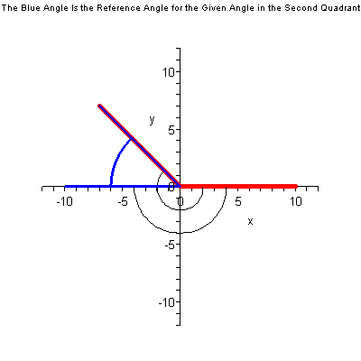

Animation of the reference angle.

$θ '$

$θ$

Relationship between $θ$ and $θ '$:
$θ ' = \left| θ \right| − π$ OR $θ ' = \left| θ \right| − \text{180} °$
OR
$π + θ ' = \left| θ \right|$ OR $\text{180} ° + θ ' = \left| θ \right|$
4. $θ$ is in the I quadrant.
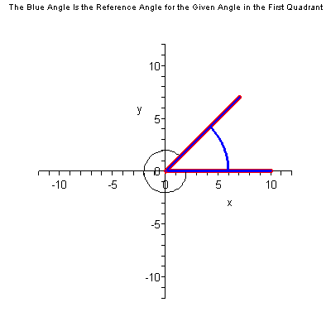

Animation of the reference angle.

$θ '$

$θ$

Relationship between $θ$ and $θ '$:
$θ ' = 2 π − \left| θ \right|$ OR $θ ' = \text{360} ° − \left| θ \right|$
OR
$\left| θ \right| + θ ' = 2 π$ OR $\left| θ \right| + θ ' = \text{360} °$

Examples Find the reference angle for the following angles.

1. $θ = \text{140} °$

The angle $θ$ is in the II quadrant.
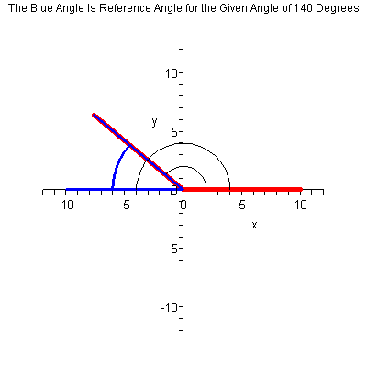

Animation of the reference angle.

$θ '$ $θ$

$θ '$ = $\text{180} ° − \text{140} ° = \text{40} °$
2. $α = − \text{350} °$

The angle $α$ is in the I quadrant.
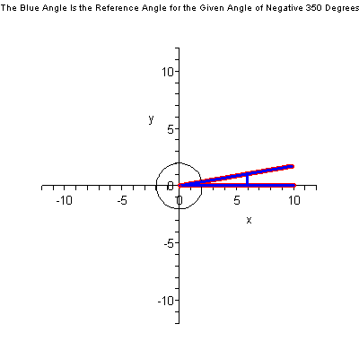

Animation of the reference angle.

$α$ $← α '$

$α '$ = $\text{360} ° − \text{350} ° = \text{10} °$

3. $β = \frac{9 π}{7}$

The angle $β$ is in the III quadrant.
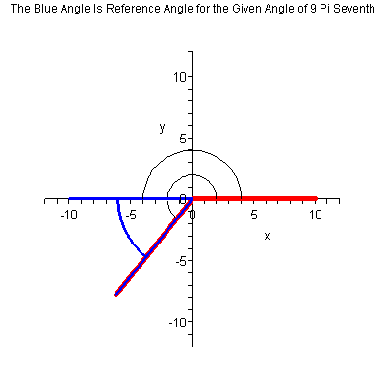

Animation of the reference angle.

$β$

$β '$
$β '$ = $\frac{9 π}{7} − π$ = $\frac{9 π}{7} − \frac{7 π}{7}$ = $\frac{2 π}{7}$
4. $φ = − \frac{9 π}{7}$

The angle $φ$ is in the II quadrant.
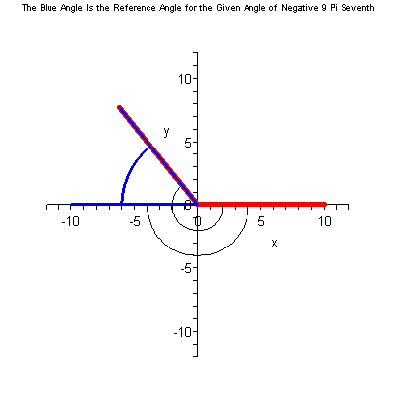

Animation of the reference angle.

$φ '$

$φ$

$φ '$ = $\frac{9 π}{7} − π$ = $\frac{9 π}{7} − \frac{7 π}{7}$ = $\frac{2 π}{7}$

5. $γ = − \frac{7 π}{\text{15}}$

The angle $γ$ is in the IV quadrant.
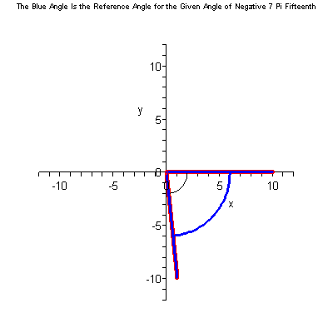

Animation of the reference angle.

$γ$
$γ '$ $γ ' = \frac{7 π}{\text{15}}$
6. $θ = \frac{\text{79} π}{\text{42}}$

The angle $θ$ is in the IV quadrant.
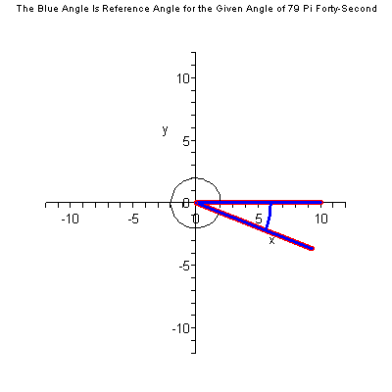

Animation of the reference angle.

$θ$

$θ '$

$θ '$ = $2 π − \frac{\text{79} π}{\text{42}}$ = $\frac{\text{84} π}{\text{42}} − \frac{\text{79} π}{\text{42}}$ = $\frac{5 π}{\text{42}}$

7. $α = − \text{150} °$
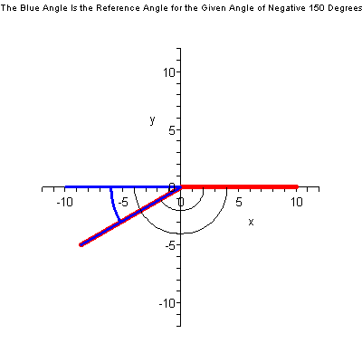

Animation of the reference angle.

$α '$ $α$

$α '$ = $\text{180} ° − \text{150} ° = \text{30} °$
8. $β = \text{180} °$

The angle $β$ is on the negative x-axis. Thus, the angle $β$ does not have a reference angle.

9. $γ = − \frac{3 π}{2}$

The angle $γ$ is on the positive y-axis. Thus, the angle $γ$ does not have a reference angle.

Back to Topics List

2. THE REFERENCE ANGLE OF THE SPECIAL ANGLES

The reference angle of the Special Angles of $± \frac{π}{6} , ± \frac{5 π}{6} , ± \frac{7 π}{6} ,$ and $± \frac{\text{11} π}{6}$ is $\frac{π}{6}$.

The reference angle of the Special Angles of $± \frac{π}{4} , ± \frac{3 π}{4} , ± \frac{5 π}{4} ,$ and $± \frac{7 π}{4}$ is $\frac{π}{4}$.

The reference angle of the Special Angles of $± \frac{π}{3} , ± \frac{2 π}{3} , ± \frac{4 π}{3} ,$ and $± \frac{5 π}{3}$ is $\frac{π}{3}$.

The reference angle of the Special Angles of $± \text{30} ° , ± \text{150} ° , ± \text{210} ° ,$ and $± \text{330} °$ is $\text{30} °$.

The reference angle of the Special Angles of $± \text{45} ° , ± \text{135} ° , ± \text{225} ° ,$ and $± \text{315} °$ is $\text{45} °$.

The reference angle of the Special Angles of $± \text{60} ° , ± \text{120} ° , ± \text{240} ° ,$ and $± \text{300} °$ is $\text{60} °$.

Back to Topics List

3. USING A REFERENCE ANGLE TO FIND THE VALUE OF THE SIX TRIGONOMETRIC FUNCTIONS

To find the value of a trigonometric function of an angle in the II, III, and IV quadrants by rotating counterclockwise, we will make use of the reference angle of the angle. To find the value of a trigonometric function of an angle in the I, II, III, and IV quadrants by rotating clockwise, we will make use of the reference angle of the angle.

Theorem Let $θ '$ be the reference angle of the angle $θ$. Then

1. $\text{cos} θ = ± \text{cos} θ '$ 4. $\text{sec} θ = ± \text{sec} θ '$

2. $\text{sin} θ = ± \text{sin} θ '$ 5. $\text{csc} θ = ± \text{csc} θ '$

3. $\text{tan} θ = ± \text{tan} θ '$ 6. $\text{cot} θ = ± \text{cot} θ '$

where the sign of + or $−$ is determined by the quadrant that the angle $θ$ is in.

We will use this theorem to help us find the exact value of the trigonometric functions of angles whose terminal side lies in the first (rotating clockwise), second, third, and fourth quadrants. We do not need any help to find the exact value of the trigonometric functions of angles whose terminal side lies on one of the coordinate axes. We know the x-coordinate and the y-coordinate of the point of intersection of these angles with the Unit Circle. So, we know the exact value of the cosine, sine, and tangent of these angles from the x-coordinate, y-coordinate, and the y-coordinate divided by the x-coordinate, respectively. This might be the reason that a reference angle is not defined for an angle whose terminal side lies on one of the coordinate axes.

The cosine, sine, and tangent of the special angles with a denominator of 6 in radian angle measurement. The cosine, sine, and tangent of the special angles with a denominator of 4 in radian angle measurement. The cosine, sine, and tangent of the special angles with a denominator of 3 in radian angle measurement.

Examples Use a reference angle to find the exact value of the six trigonometric functions of the following angles.

1. $θ = \frac{2 π}{3}$ (This is the $\text{12} 0 °$ angle in units of degrees.)

The angle $θ = \frac{2 π}{3}$ is in the II quadrant. The reference angle of the angle $θ = \frac{2 π}{3}$ is the angle $θ ' = \frac{π}{3}$.

Since the terminal side of the angle $θ = \frac{2 π}{3}$ is in the II quadrant, then the point of intersection $P \left(\frac{2 π}{3}\right)$ of the terminal side of the angle $θ = \frac{2 π}{3}$ with the Unit Circle is in the II quadrant. Thus, the x-coordinate of the point $P \left(\frac{2 π}{3}\right)$ is negative and the y-coordinate of this point is positive. Since $\text{cos} \frac{2 π}{3}$ is the x-coordinate of the point $P \left(\frac{2 π}{3}\right)$, then $\text{cos} \frac{2 π}{3}$ is negative. Since $\text{sin} \frac{2 π}{3}$ is the y-coordinate of the point $P \left(\frac{2 π}{3}\right)$, then $\text{sin} \frac{2 π}{3}$ is positive. Since $\text{tan} \frac{2 π}{3}$ is the y-coordinate of the point $P \left(\frac{2 π}{3}\right)$ divided by the x-coordinate of this point, then $\text{tan} \frac{2 π}{3}$ is negative since a positive divided by a negative is negative.

$\text{cos} \frac{2 π}{3} = − \text{cos} \frac{π}{3} = − \frac{1}{2}$ $\text{sec} \frac{2 π}{3} = − 2$

$\text{sin} \frac{2 π}{3} = \text{sin} \frac{π}{3} = \frac{\sqrt{ 3}}{2}$ $\text{csc} \frac{2 π}{3} = \frac{2}{\sqrt{ 3}}$

$\text{tan} \frac{2 π}{3} = − \text{tan} \frac{π}{3} = − \sqrt{ 3}$ $\text{cot} \frac{2 π}{3} = − \frac{1}{\sqrt{ 3}}$

2. $α = \text{210} °$ (This is the $\frac{7 π}{6}$ angle in units of radians.)

The angle $α = \text{210} °$ is in the III quadrant. The reference angle of the angle $α = \text{210} °$ is the angle $α ' = \text{30} °$.

Since the terminal side of the angle $α = \text{210} °$ is in the III quadrant, then the point of intersection $P ( \text{210} ° )$ of the terminal side of the angle $α = \text{210} °$ with the Unit Circle is in the III quadrant. Thus, the x-coordinate of the point $P ( \text{210} ° )$is negative and the y-coordinate of this point is negative. Since $\text{cos} \text{210} °$ is the x-coordinate of the point $P ( \text{210} ° )$, then $\text{cos} \text{210} °$ is negative. Since $\text{sin} \text{210} °$ is the y-coordinate of the point $P ( \text{210} ° )$, then $\text{sin} \text{210} °$ is negative. Since $\text{tan} \text{210} °$ is the y-coordinate of the point $P ( \text{210} ° )$ divided by the x-coordinate of this point, then $\text{tan} \text{210} °$ is positive since a negative divided by a negative is positive.

$\text{cos} \text{210} ° = − \text{cos} \text{30} ° = − \frac{\sqrt{ 3}}{2}$ $\text{sec} \text{210} ° = − \frac{2}{\sqrt{ 3}}$

$\text{sin} \text{210} ° = − \text{sin} \text{30} ° = − \frac{1}{2}$ $\text{csc} \text{210} ° = − 2$

$\text{tan} \text{210} ° = \text{tan} \text{30} ° = \frac{1}{\sqrt{ 3}}$ $\text{cot} \text{210} ° = \sqrt{ 3}$

3. $β = \frac{7 π}{4}$ (This is the $\text{315} °$ angle in units of degrees.)

The angle $β = \frac{7 π}{4}$ is in the IV quadrant. The reference angle of the angle $β = \frac{7 π}{4}$ is the angle $β ' = \frac{π}{4}$.

Since the terminal side of the angle $β = \frac{7 π}{4}$ is in the IV quadrant, then the point of intersection $P \left(\frac{7 π}{4}\right)$ of the terminal side of the angle $β = \frac{7 π}{4}$ with the Unit Circle is in the IV quadrant. Thus, the x-coordinate of the point $P \left(\frac{7 π}{4}\right)$ is positive and the y-coordinate of this point is negative. Since $\text{cos} \frac{7 π}{4}$ is the x-coordinate of the point $P \left(\frac{7 π}{4}\right)$, then $\text{cos} \frac{7 π}{4}$ is positive. Since $\text{sin} \frac{7 π}{4}$ is the y-coordinate of the point $P \left(\frac{7 π}{4}\right)$, then $\text{sin} \frac{7 π}{4}$ is negative. Since $\text{tan} \frac{7 π}{4}$ is the y-coordinate of the point $P \left(\frac{7 π}{4}\right)$ divided by the x-coordinate of this point, then $\text{tan} \frac{7 π}{4}$ is negative since a negative divided by a positive is negative.

$\text{cos} \frac{7 π}{4} = \text{cos} \frac{π}{4} = \frac{\sqrt{ 2}}{2}$ $\text{sec} \frac{7 π}{4} = \frac{2}{\sqrt{ 2}} = \sqrt{ 2}$

$\text{sin} \frac{7 π}{4} = − \text{sin} \frac{π}{4} = − \frac{\sqrt{ 2}}{2}$ $\text{csc} \frac{7 π}{4} = − \frac{2}{\sqrt{ 2}} = − \sqrt{ 2}$

$\text{tan} \frac{7 π}{4} = − \text{tan} \frac{π}{4} = − 1$ $\text{cot} \frac{7 π}{4} = − 1$

4. $γ = − \text{30} °$ (This is the $− \frac{π}{6}$ angle in units of radians.)

The angle $γ = − \text{30} °$ is in the IV quadrant. The reference angle of the angle $γ = − \text{30} °$ is the angle $γ ' = \text{30} °$.

Since the terminal side of the angle $γ = − \text{30} °$ is in the IV quadrant, then the point of intersection $P ( − \text{30} ° )$ of the terminal side of the angle $γ = − \text{30} °$ with the Unit Circle is in the IV quadrant. Thus, the x-coordinate of the point $P ( − \text{30} ° )$is positive and the y-coordinate of this point is negative. Since $\text{cos} ( − \text{30} ° )$ is the x-coordinate of the point $P ( − \text{30} ° )$, then $\text{cos} ( − \text{30} ° )$ is positive. Since $\text{sin} ( − \text{30} ° )$ is the y-coordinate of the point $P ( − \text{30} ° )$, then $\text{sin} ( − \text{30} ° )$ is negative. Since $\text{tan} ( − \text{30} ° )$ is the y-coordinate of the point $P ( − \text{30} ° )$ divided by the x-coordinate of this point, then $\text{tan} ( − \text{30} ° )$ is negative since a negative divided by a positive is negative.

$\text{cos} ( − \text{30} ° ) = \text{cos} \text{30} ° = \frac{\sqrt{ 3}}{2}$ $\text{sec} ( − \text{30} °) = \frac{2}{\sqrt{ 3}}$

$\text{sin} ( − \text{30} ° ) = − \text{sin} \text{30} ° = − \frac{1}{2}$ $\text{csc} ( − \text{30} ° ) = − 2$

$\text{tan} ( − \text{30} ° ) = − \text{tan} \text{30} ° = − \frac{1}{\sqrt{ 3}}$ $\text{cot} ( − \text{30} ° ) = − \sqrt{ 3}$

5. $φ = − \frac{5 π}{6}$ (This is the $− \text{15} 0 °$ angle in units of degrees.)

The angle $φ = − \frac{5 π}{6}$ is in the III quadrant. The reference angle of the angle $φ = − \frac{5 π}{6}$ is the angle $φ ' = \frac{π}{6}$.

Since the terminal side of the angle $φ = − \frac{5 π}{6}$ is in the III quadrant, then the point of intersection $P \left(− \frac{5 π}{6}\right)$ of the terminal side of the angle $φ = − \frac{5 π}{6}$ with the Unit Circle is in the III quadrant. Thus, the x-coordinate of the point $P \left(− \frac{5 π}{6}\right)$ is negative and the y-coordinate of this point is negative. Since $\text{cos} \left(− \frac{5 π}{6}\right)$ is the x-coordinate of the point $P \left(− \frac{5 π}{6}\right)$, then $\text{cos} \left(− \frac{5 π}{6}\right)$ is negative. Since $\text{sin} \left(− \frac{5 π}{6}\right)$ is the y-coordinate of the point $P \left(− \frac{5 π}{6}\right)$, then $\text{sin} \left(− \frac{5 π}{6}\right)$ is negative. Since $\text{tan} \left(− \frac{5 π}{6}\right)$ is the y-coordinate of the point $P \left(− \frac{5 π}{6}\right)$ divided by the x-coordinate of this point, then $\text{tan} \left(− \frac{5 π}{6}\right)$ is positive since a negative divided by a negative is positive.

$\text{cos} \left(− \frac{5 π}{6}\right) = − \text{cos} \frac{π}{6} = − \frac{\sqrt{ 3}}{2}$ $\text{sec} \left(− \frac{5 π}{6}\right) = − \frac{2}{\sqrt{ 3}}$

$\text{sin} \left(− \frac{5 π}{6}\right) = − \text{sin} \frac{π}{6} = − \frac{1}{2}$ $\text{csc} \left(− \frac{5 π}{6}\right) = − 2$

$\text{tan} \left(− \frac{5 π}{6}\right) = \text{tan} \frac{π}{6} = \frac{1}{\sqrt{ 3}}$ $\text{cot} \left(− \frac{5 π}{6}\right) = \sqrt{ 3}$

6. $θ = − \text{225} °$ (This is the $− \frac{5 π}{4}$ angle in units of radians.)

The angle $θ = − \text{225} °$ is in the II quadrant. The reference angle of the angle $θ = − \text{225} °$ is the angle $θ ' = \text{45} °$.

Since the terminal side of the angle $θ = − \text{225} °$ is in the II quadrant, then the point of intersection $P ( − \text{225} ° )$ of the terminal side of the angle $θ = − \text{225} °$ with the Unit Circle is in the II quadrant. Thus, the x-coordinate of the point $P ( − \text{225} ° )$is negative and the y-coordinate of this point is positive. Since $\text{cos} ( − \text{225} ° )$ is the x-coordinate of the point $P ( − \text{225} ° )$, then $\text{cos} ( − \text{225} ° )$ is negative. Since $\text{sin} ( − \text{225} ° )$ is the y-coordinate of the point $P ( − \text{225} ° )$, then $\text{sin} ( − \text{225} ° )$ is positive. Since $\text{tan} ( − \text{225} ° )$ is the y-coordinate of the point $P ( − \text{225} ° )$ divided by the x-coordinate of this point, then $\text{tan} ( − \text{225} ° )$ is negative since a positive divided by a negative is negative.

$\text{cos} ( − \text{225} ° ) = − \text{cos} \text{45} ° = − \frac{\sqrt{ 2}}{2}$ $\text{sec} ( − \text{225} °) = − \frac{2}{\sqrt{ 2}} = − \sqrt{ 2}$

$\text{sin} ( − \text{225} ° ) = \text{sin} \text{45} ° = \frac{\sqrt{ 2}}{2}$ $\text{csc} ( − \text{225} °) = \frac{2}{\sqrt{ 2}} = \sqrt{ 2}$

$\text{tan} ( − \text{225} ° ) = − \text{tan} \text{45} ° = − 1$ $\text{cot} ( − \text{225} °) = − 1$

7. $α = − \frac{5 π}{3}$ (This is the $− \text{30} 0 °$ angle in units of degrees.)

The angle $α = − \frac{5 π}{3}$ is in the I quadrant. The reference angle of the angle $α = − \frac{5 π}{3}$ is the angle $α ' = \frac{π}{3}$.

Since the terminal side of the angle $α = − \frac{5 π}{3}$ is in the I quadrant, then the point of intersection $P \left(− \frac{5 π}{3}\right)$ of the terminal side of the angle $α = − \frac{5 π}{3}$ with the Unit Circle is in the I quadrant. Thus, the x-coordinate of the point $P \left(− \frac{5 π}{3}\right)$ is positive and the y-coordinate of this point is positive. Since $\text{cos} \left(− \frac{5 π}{3}\right)$ is the x-coordinate of the point $P \left(− \frac{5 π}{3}\right)$, then $\text{cos} \left(− \frac{5 π}{3}\right)$ is positive. Since $\text{sin} \left(− \frac{5 π}{3}\right)$ is the y-coordinate of the point $P \left(− \frac{5 π}{3}\right)$, then $\text{sin} \left(− \frac{5 π}{3}\right)$ is positive. Since $\text{tan} \left(− \frac{5 π}{3}\right)$ is the y-coordinate of the point $P \left(− \frac{5 π}{3}\right)$ divided by the x-coordinate of this point, then $\text{tan} \left(− \frac{5 π}{3}\right)$ is positive since a positive divided by a positive is positive.

$\text{cos} \left(− \frac{5 π}{3}\right) = \text{cos} \frac{π}{3} = \frac{1}{2}$ $\text{sec} \left(− \frac{5 π}{3}\right) = 2$

$\text{sin} \left(− \frac{5 π}{3}\right) = \text{sin} \frac{π}{3} = \frac{\sqrt{ 3}}{2}$ $\text{csc} \left(− \frac{5 π}{3}\right) = \frac{2}{\sqrt{ 3}}$

$\text{tan} \left(− \frac{5 π}{3}\right) = \text{tan} \frac{π}{3} = \sqrt{ 3}$ $\text{cot} \left(− \frac{5 π}{3}\right) = \frac{1}{\sqrt{ 3}}$

8. $β = \text{240} °$ (This is the $\frac{4 π}{3}$ angle in units of radians.)

The angle $β = \text{240} °$ is in the III quadrant. The reference angle of the angle $β = \text{240} °$ is the angle $β ' = \text{60} °$.

$\text{cos} \text{240} ° = − \text{cos} \text{60} ° = − \frac{1}{2}$ $\text{sec} \text{240} ° = − 2$

$\text{sin} \text{240} ° = − \text{sin} \text{60} ° = − \frac{\sqrt{ 3}}{2}$ $\text{csc} \text{240} ° = − \frac{2}{\sqrt{ 3}}$

$\text{tan} \text{240} ° = \text{tan} \text{60} ° = \sqrt{ 3}$ $\text{cot} \text{240} ° = \frac{1}{\sqrt{ 3}}$

9. $γ = \frac{5 π}{6}$ (This is the $\text{15} 0 °$ angle in units of degrees.)

The angle $γ = \frac{5 π}{6}$ is in the II quadrant. The reference angle of the angle $γ = \frac{5 π}{6}$ is the angle $γ ' = \frac{π}{6}$.

$\text{cos} \frac{5 π}{6} = − \text{cos} \frac{π}{6} = − \frac{\sqrt{ 3}}{2}$ $\text{sec} \frac{5 π}{6} = − \frac{2}{\sqrt{ 3}}$

$\text{sin} \frac{5 π}{6} = \text{sin} \frac{π}{6} = \frac{1}{2}$ $\text{csc} \frac{5 π}{6} = 2$

$\text{tan} \frac{5 π}{6} = − \text{tan} \frac{π}{6} = − \frac{1}{\sqrt{ 3}}$ $\text{cot} \frac{5 π}{6} = − \sqrt{ 3}$

10. $φ = − \text{45} °$ (This is the $− \frac{π}{4}$ angle in units of radians.)

The angle $φ = − \text{45} °$ is in the IV quadrant. The reference angle of the angle $φ = − \text{45} °$ is the angle $φ ' = \text{45} °$.

$\text{cos} ( − \text{45} ° ) = \text{cos} \text{45} ° = \frac{\sqrt{ 2}}{2}$ $\text{sec} ( − \text{45} °) = \frac{2}{\sqrt{ 2}} = \sqrt{ 2}$

$\text{sin} ( − \text{45} ° ) = − \text{sin} \text{45} ° = − \frac{\sqrt{ 2}}{2}$ $\text{csc} ( − \text{45} °) = − \frac{2}{\sqrt{ 2}} = − \sqrt{ 2}$

$\text{tan} ( − \text{45} ° ) = − \text{tan} \text{45} ° = − 1$ $\text{cot} ( − \text{45} °) = − 1$

11. $θ = − \text{330} °$ (This is the $− \frac{\text{11} π}{6}$ angle in units of radians.)

The angle $θ = − \text{330} °$ is in the I quadrant. The reference angle of the angle $θ = − \text{330} °$ is the angle $θ ' = \text{30} °$.

$\text{cos} ( − \text{330} ° ) = \text{cos} \text{30} ° = \frac{\sqrt{ 3}}{2}$ $\text{sec} ( − \text{330} °) = \frac{2}{\sqrt{ 3}}$

$\text{sin} ( − \text{330} ° ) = \text{sin} \text{30} ° = \frac{1}{2}$ $\text{csc} ( − \text{330} ° ) = 2$

$\text{tan} ( − \text{330} ° ) = \text{tan} \text{30} ° = \frac{1}{\sqrt{ 3}}$ $\text{cot} ( − \text{330} ° ) = \sqrt{ 3}$

12. $α = \frac{5 π}{4}$ (This is the $\text{225} °$ angle in units of degrees.)

The angle $α = \frac{5 π}{4}$ is in the III quadrant. The reference angle of the angle $α = \frac{5 π}{4}$ is the angle $α ' = \frac{π}{4}$.

$\text{cos} \frac{5 π}{4} = − \text{cos} \frac{π}{4} = − \frac{\sqrt{ 2}}{2}$ $\text{sec} \frac{5 π}{4} = − \frac{2}{\sqrt{ 2}} = − \sqrt{ 2}$

$\text{sin} \frac{5 π}{4} = − \text{sin} \frac{π}{4} = − \frac{\sqrt{ 2}}{2}$ $\text{csc} \frac{5 π}{4} = − \frac{2}{\sqrt{ 2}} = − \sqrt{ 2}$

$\text{tan} \frac{5 π}{4} = \text{tan} \frac{π}{4} = 1$ $\text{cot} \frac{5 π}{4} = 1$

13. $β = − \frac{2 π}{3}$ (This is the $− \text{12} 0 °$ angle in units of degrees.)

The angle $β = − \frac{2 π}{3}$ is in the III quadrant. The reference angle of the angle $β = − \frac{2 π}{3}$ is the angle $β ' = \frac{π}{3}$.

$\text{cos} \left(− \frac{2 π}{3}\right) = − \text{cos} \frac{π}{3} = − \frac{1}{2}$ $\text{sec} \left(− \frac{2 π}{3}\right) = − 2$

$\text{sin} \left(− \frac{2 π}{3}\right) = − \text{sin} \frac{π}{3} = − \frac{\sqrt{ 3}}{2}$ $\text{csc} \left(− \frac{2 π}{3}\right) = − \frac{2}{\sqrt{ 3}}$

$\text{tan} \left(− \frac{2 π}{3}\right) = \text{tan} \frac{π}{3} = \sqrt{ 3}$ $\text{cot} \left(− \frac{2 π}{3}\right) = \frac{1}{\sqrt{ 3}}$

14. $φ = \frac{\text{11} π}{6}$ (This is the $\text{33} 0 °$ angle in units of degrees.)

The angle $φ = \frac{\text{11} π}{6}$ is in the IV quadrant. The reference angle of the angle $φ = \frac{\text{11} π}{6}$ is the angle $φ ' = \frac{π}{6}$.

$\text{cos} \frac{\text{11} π}{6} = \text{cos} \frac{π}{6} = \frac{\sqrt{ 3}}{2}$ $\text{sec} \frac{\text{11} π}{6} = \frac{2}{\sqrt{ 3}}$

$\text{sin} \frac{\text{11} π}{6} = − \text{sin} \frac{π}{6} = − \frac{1}{2}$ $\text{csc} \frac{\text{11} π}{6} = − 2$

$\text{tan} \frac{\text{11} π}{6} = − \text{tan} \frac{π}{6} = − \frac{1}{\sqrt{ 3}}$ $\text{cot} \frac{\text{11} π}{6} = − \sqrt{ 3}$

15. $γ = − \frac{7 π}{4}$ (This is the $− \text{315} °$ angle in units of degrees.)

The angle $γ = − \frac{7 π}{4}$ is in the I quadrant. The reference angle of the angle $γ = − \frac{7 π}{4}$ is the angle $γ ' = \frac{π}{4}$.

$\text{cos} \left(− \frac{7 π}{4}\right) = \text{cos} \frac{π}{4} = \frac{\sqrt{ 2}}{2}$ $\text{sec} \left(− \frac{7 π}{4}\right) = \frac{2}{\sqrt{ 2}} = \sqrt{ 2}$

$\text{sin} \left(− \frac{7 π}{4}\right) = \text{sin} \frac{π}{4} = \frac{\sqrt{ 2}}{2}$ $\text{csc} \left(− \frac{7 π}{4}\right) = \frac{2}{\sqrt{ 2}} = \sqrt{ 2}$

$\text{tan} \left(− \frac{7 π}{4}\right) = \text{tan} \frac{π}{4} = 1$ $\text{cot} \left(− \frac{7 π}{4}\right) = 1$

16. $θ = − \frac{4 π}{3}$ (This is the $− \text{240} °$ angle in units of degrees.)

The angle $θ = − \frac{4 π}{3}$ is in the II quadrant. The reference angle of the angle $θ = − \frac{4 π}{3}$ is the angle $θ ' = \frac{π}{3}$.

$\text{cos} \left(− \frac{4 π}{3}\right) = − \text{cos} \frac{π}{3} = − \frac{1}{2}$ $\text{sec} \left(− \frac{4 π}{3}\right) = − 2$

$\text{sin} \left(− \frac{4 π}{3}\right) = \text{sin} \frac{π}{3} = \frac{\sqrt{ 3}}{2}$ $\text{csc} \left(− \frac{4 π}{3}\right) = \frac{2}{\sqrt{ 3}}$

$\text{tan} \left(− \frac{4 π}{3}\right) = − \text{tan} \frac{π}{3} = − \sqrt{ 3}$ $\text{cot} \left(− \frac{4 π}{3}\right) = − \frac{1}{\sqrt{ 3}}$

17. $β = \frac{3 π}{4}$ (This is the $\text{135} °$ angle in units of degrees.)

The angle $β = \frac{3 π}{4}$ is in the II quadrant. The reference angle of the angle $β = \frac{3 π}{4}$ is the angle $β ' = \frac{π}{4}$.

$\text{cos} \frac{3 π}{4} = − \text{cos} \frac{π}{4} = − \frac{\sqrt{ 2}}{2}$ $\text{sec} \frac{3 π}{4} = − \frac{2}{\sqrt{ 2}} = − \sqrt{ 2}$

$\text{sin} \frac{3 π}{4} = \text{sin} \frac{π}{4} = \frac{\sqrt{ 2}}{2}$ $\text{csc} \frac{3 π}{4} = \frac{2}{\sqrt{ 2}} = \sqrt{ 2}$

$\text{tan} \frac{3 π}{4} = − \text{tan} \frac{π}{4} = − 1$ $\text{cot} \frac{3 π}{4} = − 1$

18. $β = \text{300} °$ (This is the $\frac{5 π}{3}$ angle in units of radians.)

The angle $β = \text{300} °$ is in the IV quadrant. The reference angle of the angle $β = \text{300} °$ is the angle $β ' = \text{60} °$.

$\text{cos} \text{300} ° = \text{cos} \text{60} ° = \frac{1}{2}$ $\text{sec} \text{300} ° = 2$

$\text{sin} \text{300} ° = − \text{sin} \text{60} ° = − \frac{\sqrt{ 3}}{2}$ $\text{csc} \text{300} ° = − \frac{2}{\sqrt{ 3}}$

$\text{tan} \text{300} ° = − \text{tan} \text{60} ° = − \sqrt{ 3}$ $\text{cot} \text{300} ° = − \frac{1}{\sqrt{ 3}}$

19. $α = − \frac{7 π}{6}$ (This is the $− \text{21} 0 °$ angle in units of degrees.)

The angle $α = − \frac{7 π}{6}$ is in the II quadrant. The reference angle of the angle $α = − \frac{7 π}{6}$ is the angle $α ' = \frac{π}{6}$.

$\text{cos} \left(− \frac{7 π}{6}\right) = − \text{cos} \frac{π}{6} = − \frac{\sqrt{ 3}}{2}$ $\text{sec} \left(− \frac{7 π}{6}\right) = − \frac{2}{\sqrt{ 3}}$

$\text{sin} \left(− \frac{7 π}{6}\right) = \text{sin} \frac{π}{6} = \frac{1}{2}$ $\text{csc} \left(− \frac{7 π}{6}\right) = 2$

$\text{tan} \left(− \frac{7 π}{6}\right) = − \text{tan} \frac{π}{6} = − \frac{1}{\sqrt{ 3}}$ $\text{cot} \left(− \frac{7 π}{6}\right) = − \sqrt{ 3}$

20. $γ = − \text{135} °$ (This is the $− \frac{3 π}{4}$ angle in units of radians.)

The angle $γ = − \text{135} °$ is in the III quadrant. The reference angle of the angle $γ = − \text{135} °$ is the angle $γ ' = \text{45} °$.

$\text{cos} ( − \text{135} ° ) = − \text{cos} \text{45} ° = − \frac{\sqrt{ 2}}{2}$ $\text{sec} ( − \text{135} °) = − \frac{2}{\sqrt{ 2}} = − \sqrt{ 2}$

$\text{sin} ( − \text{135} ° ) = − \text{sin} \text{45} ° = − \frac{\sqrt{ 2}}{2}$ $\text{csc} ( − \text{135} °) = − \frac{2}{\sqrt{ 2}} = − \sqrt{ 2}$

$\text{tan} ( − \text{135} ° ) = \text{tan} \text{45} ° = 1$ $\text{cot} ( − \text{135} °) = 1$

21. $θ = − \frac{π}{3}$ (This is the $− \text{60} °$ angle in units of degrees.)

The angle $θ = − \frac{π}{3}$ is in the IV quadrant. The reference angle of the angle $θ = − \frac{π}{3}$ is the angle $θ ' = \frac{π}{3}$.

$\text{cos} \left(− \frac{π}{3}\right) = \text{cos} \frac{π}{3} = \frac{1}{2}$ $\text{sec} \left(− \frac{π}{3}\right) = 2$

$\text{sin} \left(− \frac{π}{3}\right) = − \text{sin} \frac{π}{3} = − \frac{\sqrt{ 3}}{2}$ $\text{csc} \left(− \frac{π}{3}\right) = − \frac{2}{\sqrt{ 3}}$

$\text{tan} \left(− \frac{π}{3}\right) = − \text{tan} \frac{π}{3} = − \sqrt{ 3}$ $\text{cot} \left(− \frac{π}{3}\right) = − \frac{1}{\sqrt{ 3}}$

Back to Topics List

